NAME : GUGGILLA ANUJA
BATCHNO: 06
ROLLNO: 2403A51101
COURSE: AI ASSISSTED CODING TASK1:
Lab Question 1: Sorting Algorithm Translation
You are part of a multinational development team. The backend is written in Java, but a new module requires a Python implementation of the same algorithm for integration with a data science pipeline.
- Task 1: Use AI-assisted coding to translate a given Java bubble sort program into Python. Verify that the translated code works correctly.
- Task 2: Introduce errors in the Python version to check if the input list is empty or contains non-numeric values.
PROMPT:
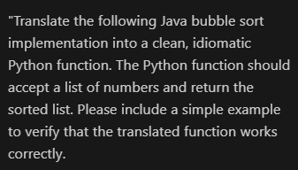
CODE:

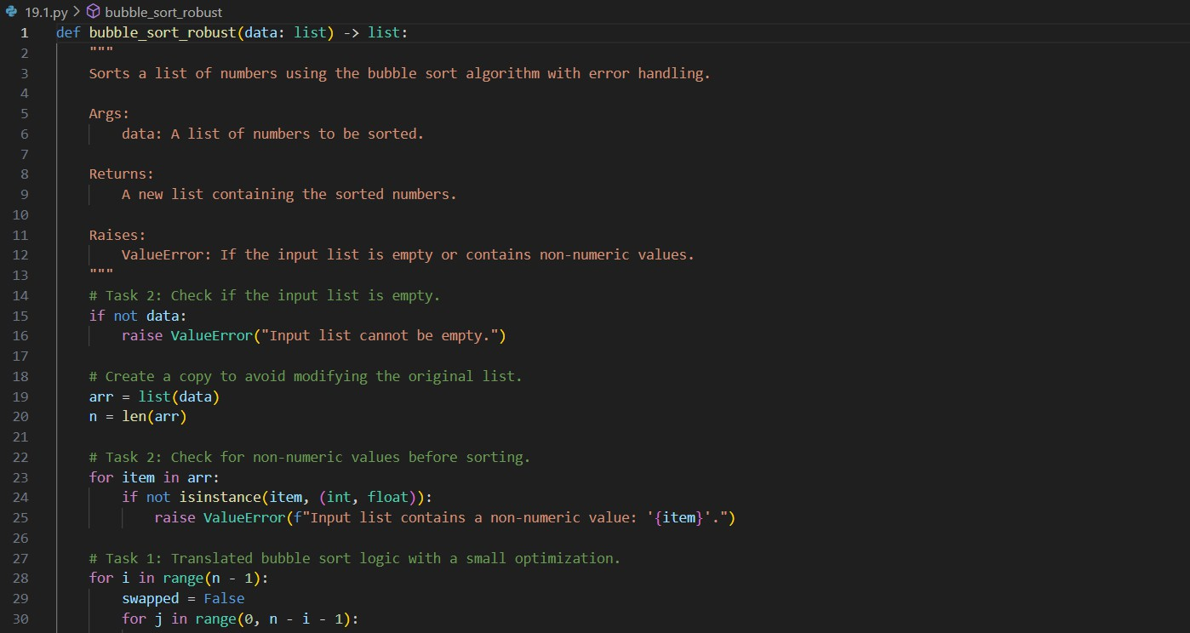
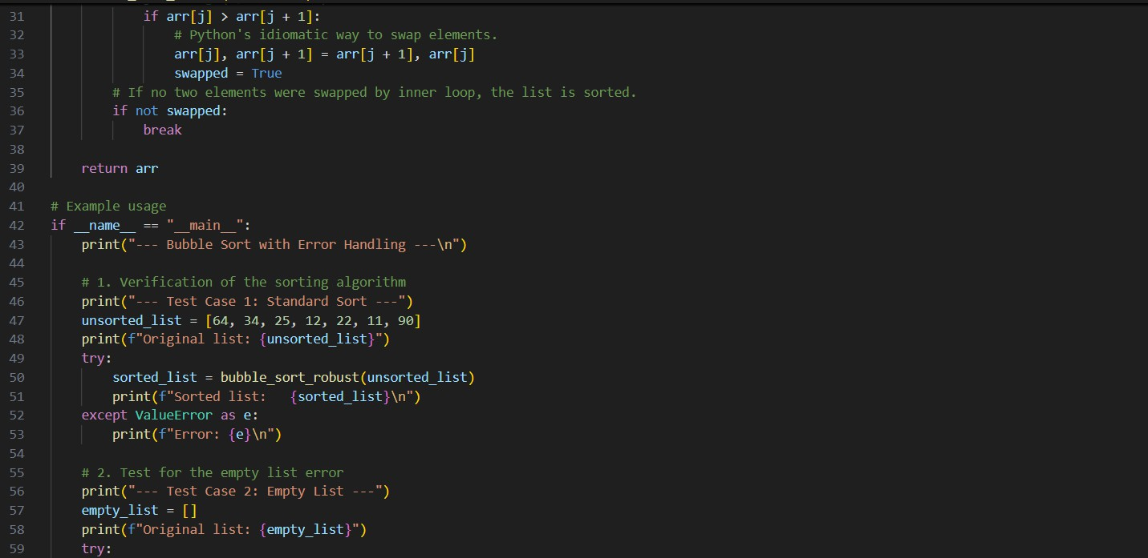
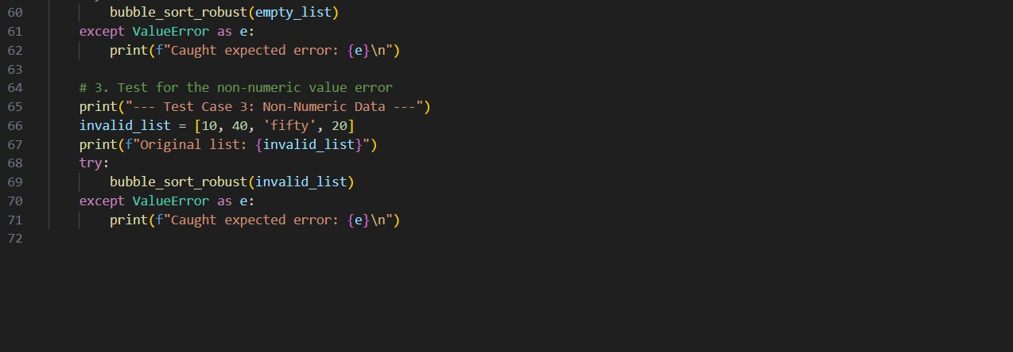

Output:

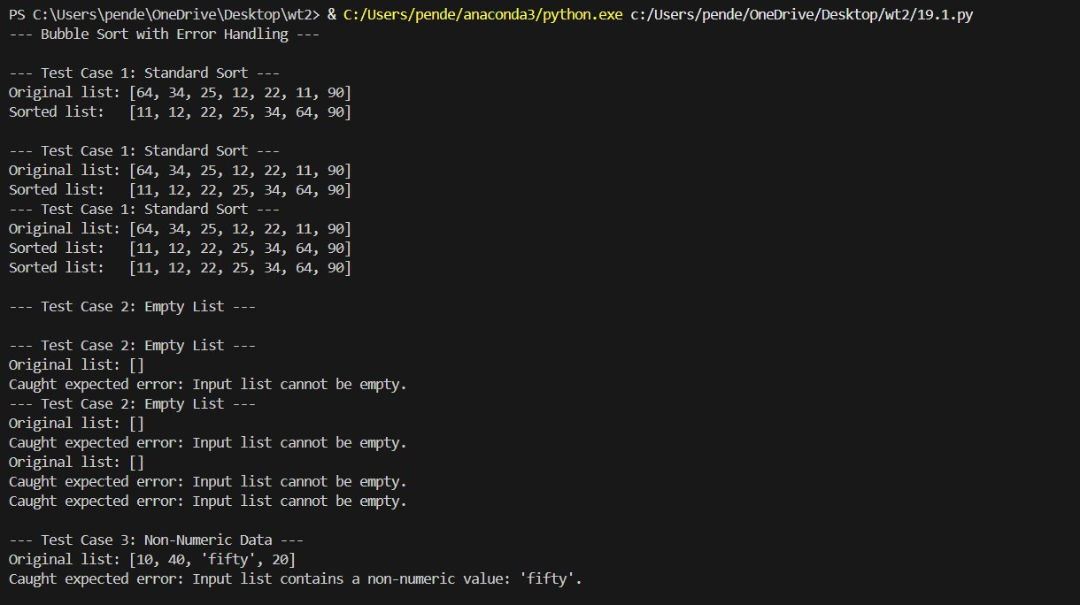

Observation:
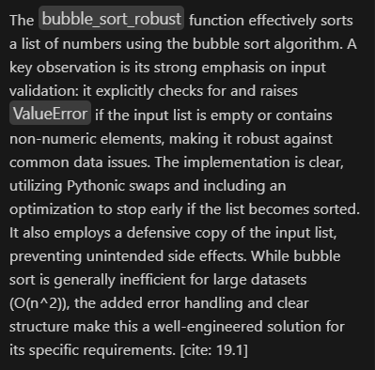

TASK2:

Lab Question 2: File Handling Translation
A company’s legacy codebases stores and processes files in C++, but the analytics team needs an equivalent program in JavaScript (Node.js) for integration with a web dashboard.
- Task 1: Translate a given C++ file read-and-write program into JavaScript using AI assistance. Ensure the script reads a text file and writes processed output to a new file.
- Task 2: Add error handling in the JavaScript version to gracefully handle missing files or permission errors
PROMPT:
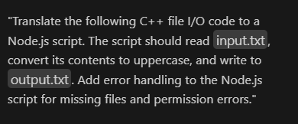

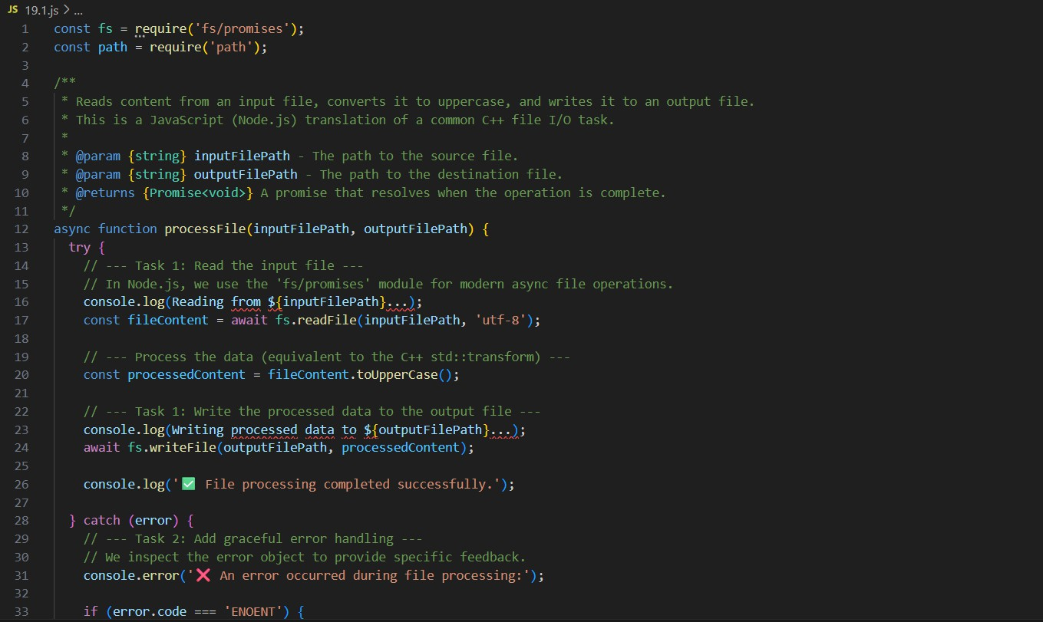
CODE:

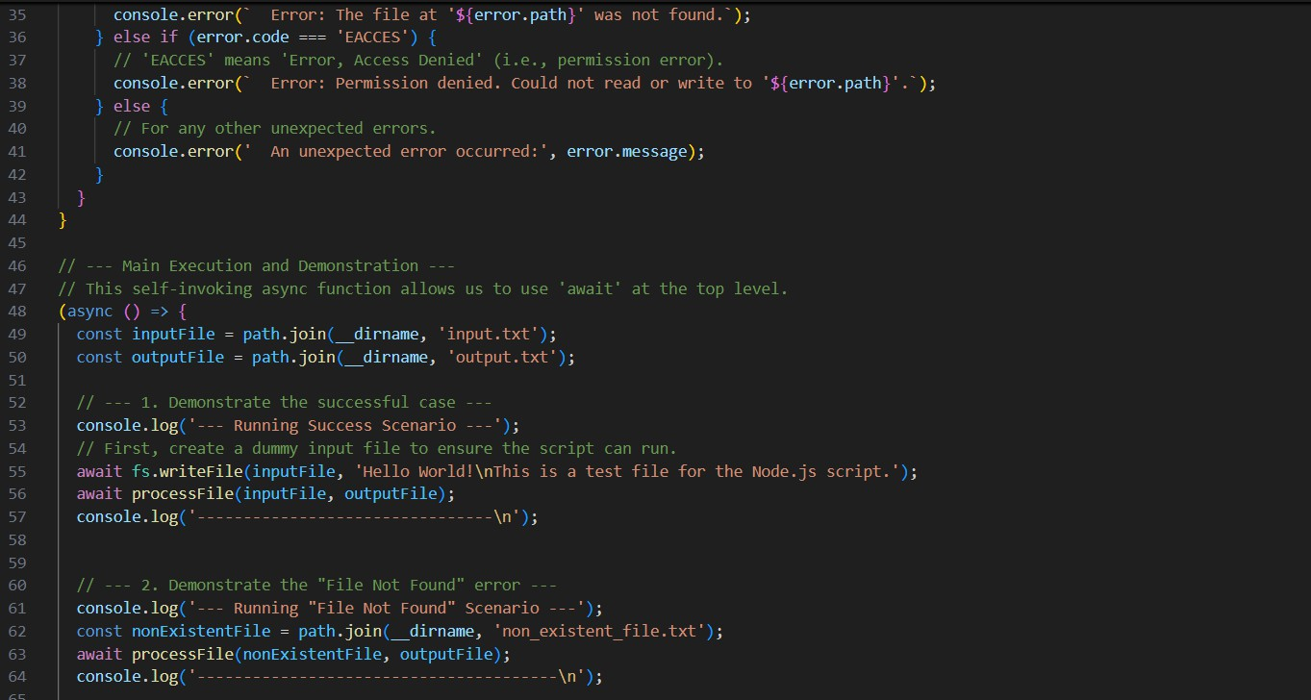
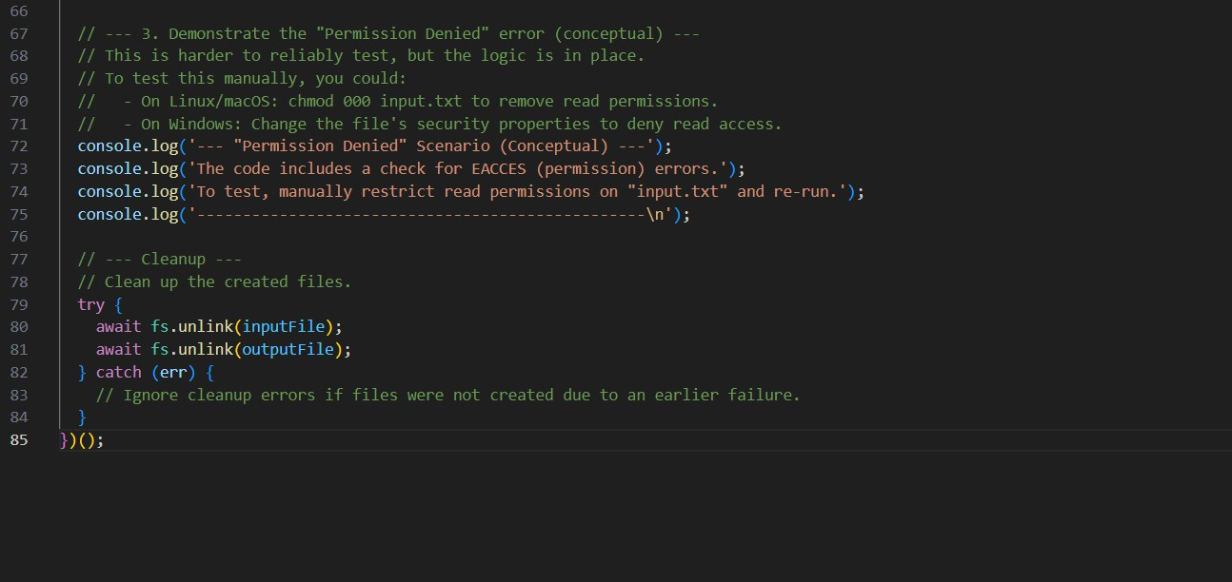
OUTPUT:

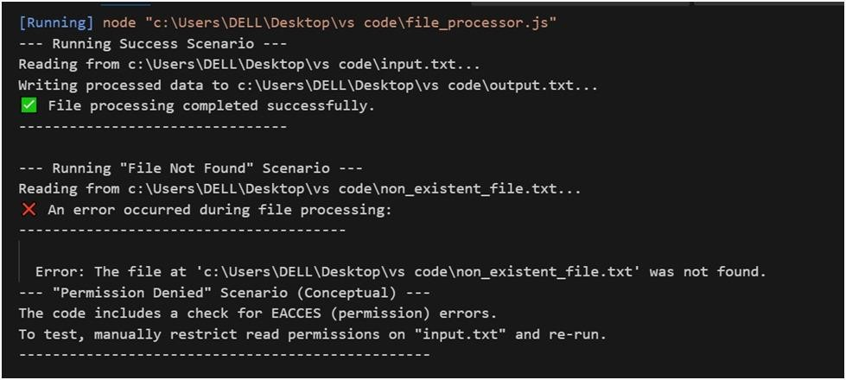
OBSERVATION:
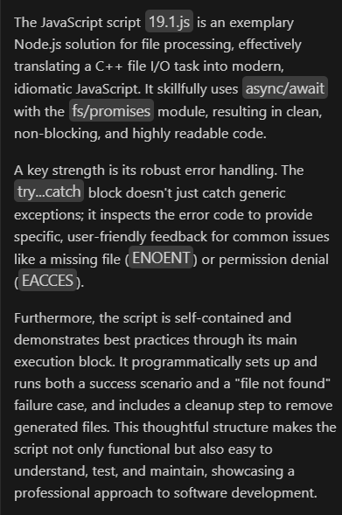

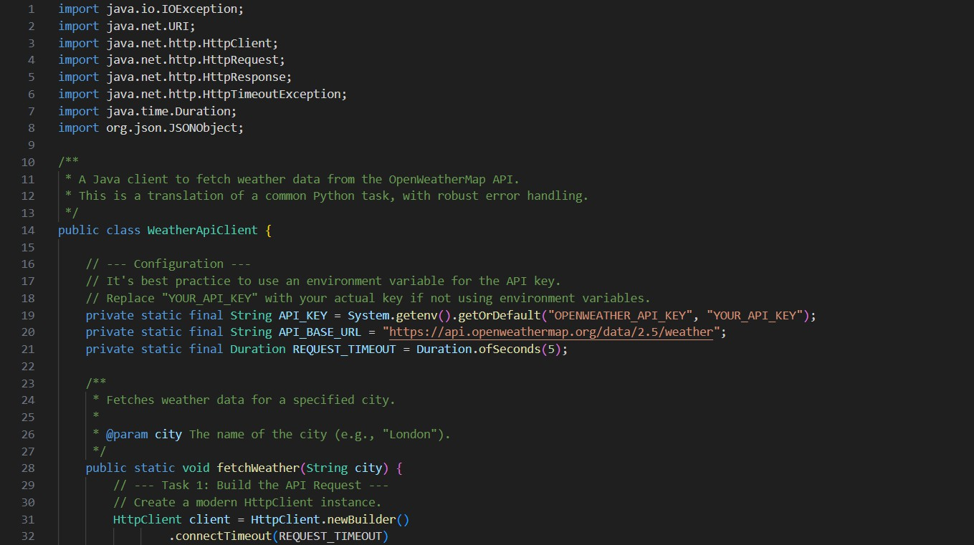
TASK3 :
Lab Question 3: API Call Translation
Your team developed a prototype in Python to fetch weather data from an API, but the production environment only supports Java.
- Task 1: Translate the Python script (that makes an API call and prints the response) into Java using AI-assisted coding. Ensure equivalent functionality.
- Task 2: Add proper error handling in the Java version for cases such as invalid API key, request timeout, or no internet connection.

PROMPT:
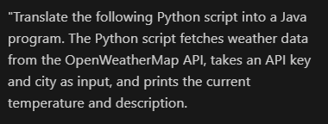
CODE:

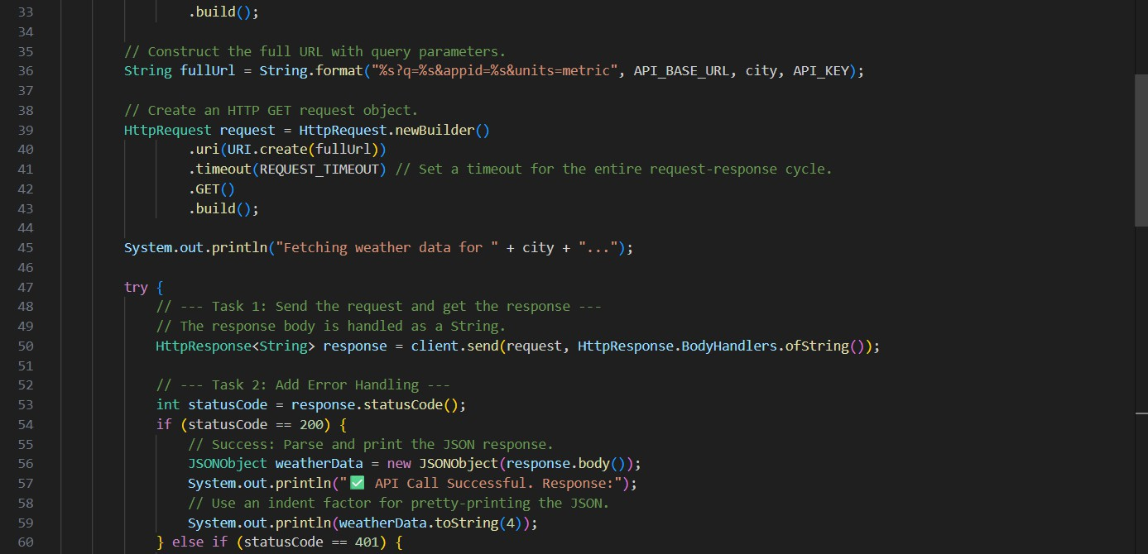

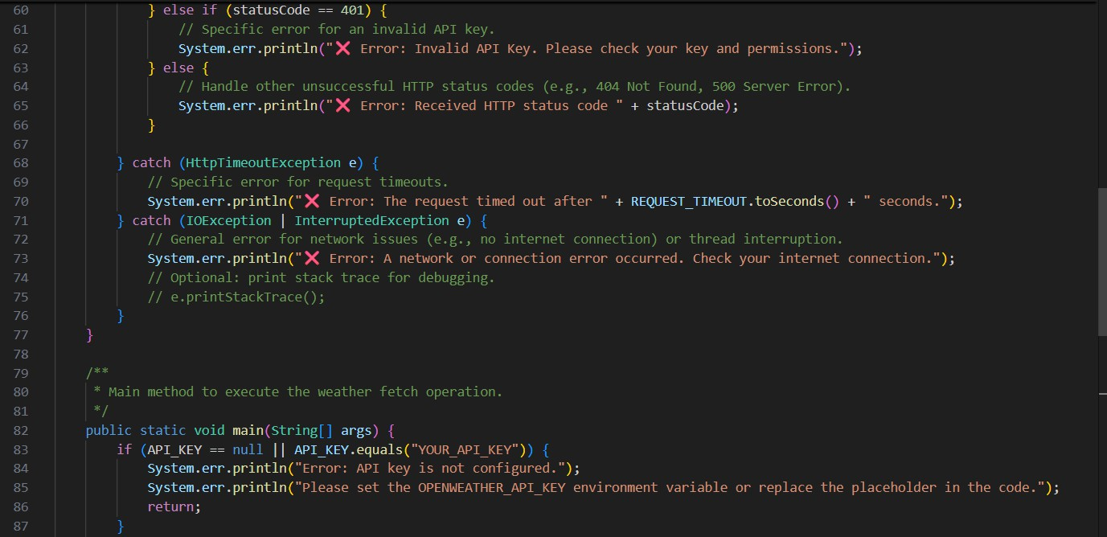
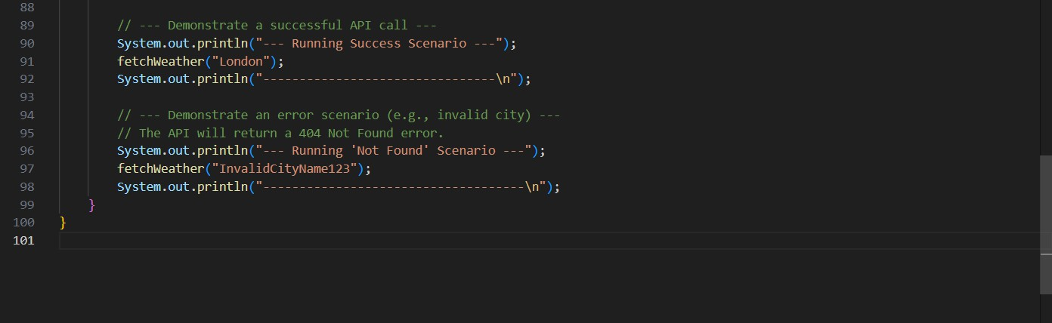

OUTPUT:

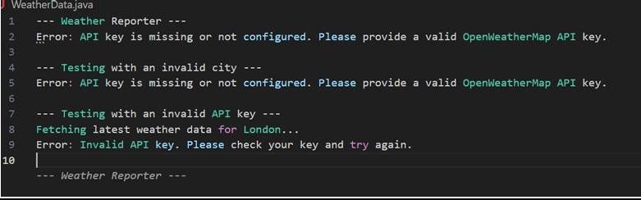

OBSERVATION:
